**PRIMARY THREE**

**RELIGIOUS EDUCATION**

**LESSON NOTES**

**FOR**

**TERM 1**

**WEEK1**: Lesson 1

**THEME 1: CHRISTIANS GROW IN JESUS**

**TRADITIONS/ CUSTOMS**

1. What is a custom?

*A Custom* *is an acceptable behaviour in a given society*

**2. Examples of traditional practices /customs in our society**

* Greeting *people*.
* Naming twins.
* Bowing down before kings.
* Paying bride price.
* Having last funeral rites.
* Dressing
* Welcoming visitors at home.
* *Initiation ceremonies like circumcision among the Bagisu*
* *marriage*

**3. People who teach us customs include**:

* Parents
* Teachers
* Pastors
* Elders
* Grand parents

**Activity**

1. **What term is used to mean the traditional practices of a society?**
2. **Name two traditions among the Baganda**
3. **Draw and colour yourself performing any one custom at home.**

|  |
| --- |
|  |

1. *Why do Christians celebrate Christmas?*
2. *How do we call the fasting period for Christmas?*
3. *Write your religious name*

**WEEK1**: Lesson 2

**Importance of customs in our society**

(a)**Greeting;**

* Creates friendship
* Sign of respect
* Makes people feel happy.

(b) **Paying bride price/wealth;**

* Sign of thanks you to the girl’s family.
* Sign of responsibility.
* To stabilize marriage.

(c) **Naming children;**

* For identification
* Creates unity among clan members.

(d) **Welcoming visitors;**

* + To show respect.
  + To create friendship.

(e) **Mourning for the dead;**

* Way of showing sorrow.
* Sign of love for the dead.

**Activity**

1. **Name any two customs at school.**
2. **Why we greet one another?**
3. **What do you do when you receive a visitor?**
4. *Write C.R.E in full.*
5. *Who died for our sins on the cross?*
6. *Who was the founder of Islam?*

**WEEK2**: Lesson 1

***General importance of customs***

* *They create unity*
* *They make identification of a certain group of people*
* *They create happiness*
* *Some traditions and customs are signs of being grateful.*

**Customs in the Christian family**

1. Christian customs help to unite us in God’s family

**2. Examples of Christian customs;**

* Attending church services.
* Baptism (John 1:29-34)
* Confirmation (acts: 8: 14 – 20)
* Holy marriage / *matrimony*
* Fasting during lent period.
* Praying for the sick.
* Praying before a meal.
* Paying tithes and offertories.
* *Holy communion (John 2:1 – 15)*
* *Helping the needy*
* *Repenting*

3. What is the importance of baptism in Christian family?

* To wash away the original sin.
* To bring us into God’s family.

**Activity**

1. **Name any two Christian customs.**
2. **Which custom helps a man and woman to be husband and wife?**
3. **Why do we pay tithes and offertories?**
4. **Draw, name and colour any one Christian custom.**

|  |
| --- |
|  |
|  |

1. *How do Christians enter God’s family?*
2. *Name any three examples of religious leaders*

**WEEK2**: Lesson 2

**Other customs we meet**

1. Each society has its own customs e.g.

The Baganda bow down before their Kabaka

2. Why should we respect other people’s customs?

* To fit in every society.
* To live happily with other people.
* To learn the behavior of other people.

**TOPICAL TEST**

1. What are customs?
2. Give two examples of customs in your society
3. Why do Baganda women and girls kneel while greeting?
4. Mention any two Christian customs?
5. Of what importance is baptism to a Christian?
6. In which place did Jesus attend the wedding ceremony?
7. *Name any two miracles performed by Jesus.*
8. *On which day did the apostles receive the Holy Spirit?*
9. *Who calls Moslems for prayers*?
10. *Name any three apostles of Jesus*

**WEEK3**: Lesson 1

**LEADERSHIP**

**Read;**

Eph 4:11-13

Mark9:33-35

1. What is leadership?

Leadership is a position of guiding or managing others

2. Who is a leader?

-A person given a responsibility of guiding others.

-A leader is a person who guides or manages others.

**3. Examples of leaders include:**

* president
* A head teacher
* Classteachers
* Head prefect
* Class prefects
* Pastors
* Bishops
* Kings

4. **Qualities of a good leader**

**1 Tim3:1-7**

* Should lead by example.
* Should be a good listener.
* Should make good decisions.
* Should be kind
* Should not be God-fearing.
* Should be patient.
* *Should be humble*
* *Should be trustworthy*
* *Should be faithful*

**Activity**

**1. Who is a leader?**

**2. Give any two qualities of a good leader.**

**3. Who heads a church?**

**4. *Who was the earthly father of Jesus?***

***5. Which Prophet built the Kaaba?***

***6. What title is given to a person who heads a country?***

**WEEK3**: Lesson 2

**Levels of leadership in our society**

- At different levels and places, we have different leaders

These include:

**(a)At family level;**

* Father
* Mother

**(b)At school level;**

* Head teacher
* Deputy head teachers
* Heads of department
* Class teachers
* Prefects etc

**(c)At church level;**

**Read;**

Eph 4:11-13

* Bishops
* priests
* Reverends
* Pastors
* Deacons and ushers

**(d)At community level;**

* L C 3 Chairperson at the sub-county level
* L C 2 Chairperson at the parish level
* L C 1 chairperson at the village level

**(e)At clan level**

* Clan head
* Lineage head
* Family heads

**Activity**

* 1. **Mention any two leaders at school.**
  2. **Who heads a family?**
  3. ***Write your religious name?***
  4. ***Who is a leader?***
  5. ***Who leads prayers in the mosque?***
  6. ***In which city was Jesus born?***

**WEEK4**: Lesson 1

**1. Examples of leaders in the Old Testament**

* Abraham
* Moses
* Joshua
* Samuel
* Ruth
* Kings like David, Solomon etc

**A). ABRAHAM AS A LEADER**

Gen 12:1-5

Gen22

1. Abraham’s wife was Sarah.
2. They lived in a country called **Haran (Ur).**
3. God told Abraham to leave his homeland and go to another land.
4. **Canaan** was the new land God promised Abraham.
5. **Isaac** was the son God gave to Abraham and Sarah.
6. God asked Abraham to sacrifice his only son, **Isaac**.
7. *Abraham’s father was Terah.*
8. *Hagar( slave) gave birth to Ishmael*
9. *Abraham was circumcised at the age of 80*

[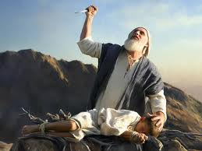](http://1.bp.blogspot.com/-euiMG_x7fkI/UP2arpwbzUI/AAAAAAAABss/tZ004hTL9YE/s1600/abraham.jpeg)

1. When Abraham obeyed, God made him **the grandfather of all nations.**
2. *The symbol of God’s covenant with Abraham was circumcision*
3. *Abraham died at the age of 175 years*

***How Abraham expressed his faithfulness to God?***

1. *He accepted to sacrifice his son Isaac.*
2. *He accepted to leave his homeland to unknown land.*
3. *He accepted to change his name from Abram to Abraham.*
4. *He allowed to be circumcised at the age of 80 years.*

***God’s promises to Abraham***

* *To have many descendants/ grand children.*
* *To bless him and become famous*
* *To bless those who bless him*
* *To curse those who curse him.*

***Children of Abraham***

* *Ishmael – Hagar*
* *Isaac – Sarah*
* *Zimran*
* *Medan*
* *Ishbak Ketrah*
* *Jokshan*
* *Midian*

**Activity**

1. **Who was the wife of Abraham?**
2. **Which land was promised to Isaac?**
3. **Why did God ask Abraham to sacrifice his son?**
4. ***Name any three leaders in the Old Testament.***
5. ***What was Abraham’s name before the call?***

**WEEK4**: Lesson 2

**b).MOSES AS A LEADER OF GOD**

**Exodus 3**

|  |
| --- |
| **http://www.bridgetothebible.com/images/Moses%20as%20leader.jpg Moses** |

Number 20:10  
*The name Moses means got from water (Pulled out of water)*

Moses was a shepherd before he became a leader.

1. God first appeared to Moses on **Mt Sinai** in form of a burning bush.
2. Moses was told lead the Israelites from Egypt to the Promised Land.
3. He led the Israelites out of Egypt across the **Red sea**.
4. Moses died on the way because he disobeyed God.
5. He died on **Mt Nebo**  and  *buried in a valley of Moab.*
6. *He reviewed the promised land on Mt. Pisgah*.
7. *His father was Amram and the mother was Joshebed.*
8. *His wife was Zipporah*

***Sons of Moses***

* *Gershom*
* *Eliezer*

**Activity**

1. **Who led the Israelites out of Egypt?**
2. **Name the water body which was crossed by the Israelites from Egypt.**
3. **In which form did God first appear to Moses?**
4. **Why didn’t Moses reach the Promised Land?**

**WEEK5**: Lesson 1

**JOSHUA AS A LEADER OF GOD**

**Joshua1:1-3**

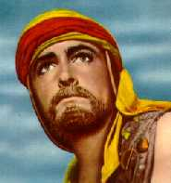

1. Joshua succeeded Moses.
2. He led the Israelites across **River Jordan** to the Promised Land.
3. The Promised Land was called **Canaan.**

**4. Qualities of leaders in the Old Testament**

* They were God-fearing.
* They were obedient
* They were faithful.
* They wear brave.

**Activity**

1. **Who lead the Israelites to the Promised Land?**
2. **Name the river which was crossed by the Israelites to the Promised Land.**

**3. What was the name of the Promised Land?**

**4. Give any two qualities of leaders in the Bible.**

**WEEK5**: Lesson 2

**JESUS AS A LEADER**

**Read;**

Mark10:13-15

John2:13-16

[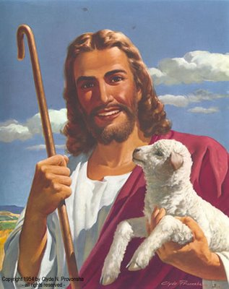](http://2.bp.blogspot.com/_mSxLFTmqqRs/SaIPNglbDSI/AAAAAAAAAHM/VDhHoCk09uI/s1600-h/jesus+smiling.jpg)

1. How was Jesus Christ a good leader?

* Jesus was a servant of all people.
* Jesus treated all people fairly.
* He was humble.
* He was loving and caring.
* He was obedient to the law.
* He was God fearing.

**Activity**

1. **Give two ways in which Jesus was a good leader.**
2. **What lesson do we learn from Jesus?**
3. **Mention any two qualities of a bad leader.**
4. **Draw and show Jesus with the little children**

**WEEK6**: Lesson 1

**MESSENGERS OF GOD**

**How God speak to us**

Isaiah6:1-10

1Sam13:1-21

1. Mention the ways how God speaks to us

* Through the Bible
* Using *religious leaders, pastors and priests*
* Through dreams
* Through visions
* *Through revelations*
* *Through life experience*
* *Through direct communication*

2. Who is a prophet?

A prophet is a messenger of God.

3. E**xamples of prophets in the Bible**

* John the Baptist
* Isaiah
* Jeremiah
* Elijah
* Noah
* Joel
* Moses
* Amos
* Micah
* Ezekiel

**4. Qualities of people chooses to be his messengers**

* They are faithful
* They are trustworthy
* They are obedient
* They are not proud
* They humble

**Activity**

1. **List any two way how God can speaks to us.**
2. **Who is a prophet?**
3. **Mention any three prophets in the Bible.**

**WEEK6**: Lesson 2

**NOAH AS A MESSENGER**

**Gen 6:1-8**

1. God told Noah to build the big boat called **the Ark**.
2. The Ark saved Noah, his family and other creatures from the flood.

[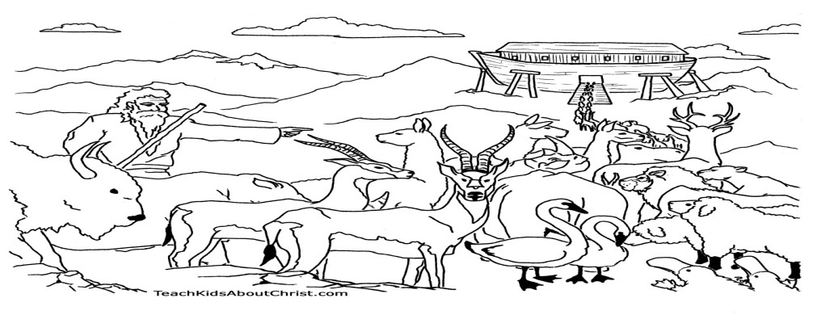](http://teachkidsaboutchrist.com/wp-content/uploads/2010/09/Noahs-Ark-Coloring-Page.jpg)

1. It flooded for **40 days and nights**
2. ***Eight people survived the floods***
3. **The names of Noah’s sons were**:
   1. Shem
   2. Ham
   3. Japheth
4. Noah’s ark rested on **Mountain Ararat**.

Ham -  *was cursed by his father Noah for looking at his nakedness when Noah was drunk*

1. *The symbol of God’s covenant with Noah was* ***rainbow*** *Noah Died at the age of 950 years.*

**Activity**

1. **Who built the ark?**
2. **For how long was the flood in Noah’s time?**
3. **On which mountain did the Ark rest?**

**WEEK7**: Lesson 1

**Angels as God’s messenger**

**Read:**

Luke1:26-38

1. Who are angels?

Angels are heavenly messengers of God.

1. **Angel Gabriel** brought the message to **Mary** about the birth of Jesus Christ.

* *Birth of John the Baptist.*
* *Message to the shepherds about the Birth of Christ*

***Other examples of angels***

* *Angel Michael*
* *Angel Raphael*

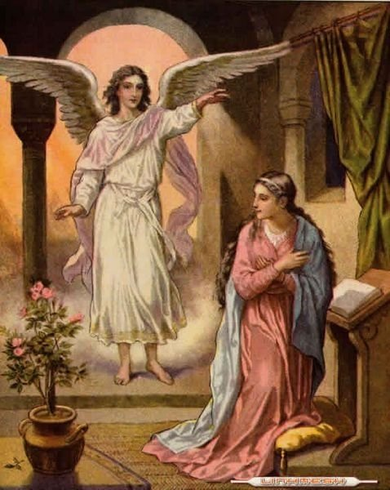

***Quantities of angel***

* *They were created from light.*
* *They have supernatural power.*
* *They do not drink nor eat.*
* *They are invisible.*
* *They are neither males and females.*
* *They have wings.*

**Activity**

1. **How is an angel different from a prophet?**
2. **Which angel brought the good news to Mary?**
3. **What do we learn from virgin Mary?**

**WEEK7**: Lesson 2

**Messages about Jesus from God’s messengers**

(a)**Prophet Isaiah** (Isa 53)

* + He talked about the coming of Jesus.
  + He said that Jesus would suffer on behalf of Christian.
  + That Jesus would be beaten, wounded and killed.

(b) **Prophet Micah** (Micah 5:2)

He said that Jesus would be born in the town called **Bethlehem**.

(c) **Prophet Zechariah** (Zech 9:9)

* He also said that Jesus would go to Jerusalem on a donkey. ( a colt)

(d) **John the Baptist**

* He was the last prophet in the Bible
* He prepare for the coming of Jesus Christ.
* He baptized Jesus at River Jordan.

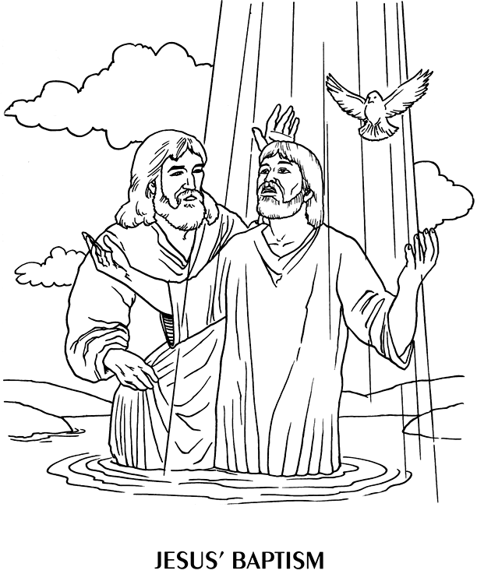

**Activity**

1. **Which prophet said that Jesus would beat and killed?**
2. **In which town was Jesus born?**
3. **Who baptized Jesus?**
4. **Name the river where Jesus was baptized.**

**WEEK**:8 Lesson 1

**SORROW AND JOY IN LIFE**

**LENT**

**Read;**

**Matt6:16-18**

1. What is lent?

Lent is the fasting period for Christians.

2. Lent period lasts for forty (40) days.

3. Christians begin their lent on **Ash Wednesday and Palm sunday**

**4. Reasons why Christians fast**

* To repent of their sins
* To strengthen their faith
* To get blessings
* *To ask for their needs.*

**5. What should a Christian do during lent**?

* Repenting his/her sins
* Forgiving others
* Praying to God
* Reading the Bible

**Activity**

1. **What do we call the fasting period for Christians?**
2. **When do Christians begin fasting?**

**3. Mention any three things a Christian should not do during lent.**

**4. Why do Christians fast?**

**5.** *How many days do Christians fast?*

*6. What should one do after sinning?*

WEEK:8 Lesson 2

**Jesus’ stay in the wilderness**

**Read;**

Luke 4:1-12

1. Jesus was in the wilderness for 40 days and nights.

2. He was fasting and praying.( with out food or drinks)

3. He was tempted by devil or Satan three times .

[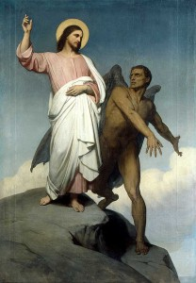](http://prophetsandpopstars.com/wp-content/uploads/2012/02/temptation_jesus22.jpg)

**Temptations given to Jesus**

1. To turn the rock (stone) into bread.
2. To bow down and worship the devil.
3. To fall down from the highest point of the temple.

**Activity**

1. **For how long was Jesus in the wilderness?**
2. **Who tempted Jesus?**
3. **Mention any one temptation given to Jesus.**
4. **What should we do when we are tempted?**
5. ***Mention any two miracles performed by Jesus***
6. ***What did God create first?***

WEEK: 9 Lesson 1

**THE HOLY WEEK**

**Read;**

Mark 14 & 15

1. What was known as the **Holy week**?

It was the week in which Jesus died for our sins.

**2. What happened during the Holy Week?**

**a)Palm Sunday** (John 12:12-19) (***prophet zechariah)***

Jesus entered Jerusalem riding a donkey.

**b)Holy Thursday**

Jesus had the last supper with his apostles.

**c) Good Friday**

Jesus was crucified/nailed on the cross.

**d) Easter Sunday**

Jesus resurrected or rose from the dead.

**Activity**

**Match the following correctly.**

**A B**

Palm Sunday -Jesus rose from the dead.

Good Friday -Jesus entered Jerusalem on a donkey.

Easter Sunday -Jesus had his last supper.

Holy Thursday -Jesus was crucified.

**WEEK:9 Lesson 2**

**THE LAST SUPPER**

**Read;**

Luke 22:14-23

1. What was the Last Supper?

This was the last meal Jesus had with his apostles.

2. Jesus had the last supper on the **Holy Thursday**.

3. They used bread and wine during the Last Supper.

4. The **bread** represented the **body** of Jesus Christ.

5. The **wine** represented the **blood** of Jesus Christ.

6. *Simon Peter and John prepared the last supper*

*7. He also washed his apostles feet as a sign of love.*

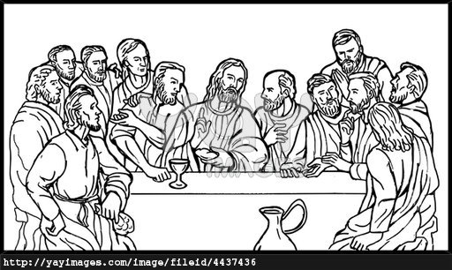

1. Christians today celebrate the Lord’s Supper through the **Holy Communion or Holy Eucharist**.

***EVENTS***

* *Washing of apostles feet*
* *Praying in the garden*
* *Betrayal of Jesus*

**Activity**

* 1. **On which did Jesus have his Last supper?**
  2. **Name the two things that were used during the Last supper?**
  3. **What do the following represent during Holy Communion?**

1. **the bread**
2. **the wine**
   1. ***How many apostles did Jesus have?***
   2. ***Name any two apostles who prepared the last supper***

**WEEK:10 Lesson 1**

**JESUS’ CRUCIFIXION AND DEATH**

**Read;**

Matthew 27; 32-53

Luke 22:14-9-23 [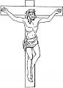](http://www.google.com/imgres?imgurl=http://www.supercoloring.com/wp-content/main/2010_04/jesus-on-the-cross-coloring-page.jpg&imgrefurl=http://www.supercoloring.com/pages/jesus-on-the-cross/&usg=__JW-EdGt9RjQ-KwLSRK0RaTFXfYk=&h=350&w=250&sz=24&hl=en&start=10&zoom=1&tbnid=95t24eBFaXgJRM:&tbnh=120&tbnw=86&ei=bsWrT4nNIYyyhAeOn8ydCg&prev=/search?q=jesus+on+the+cross&hl=en&gbv=2&tbm=isch&itbs=1)

***Good Friday Events***

* ***Arrest***
* ***Betrayal Judas***
* ***Trial***
* ***Burial***
* ***Roman soldiers***
* ***Joseph of Arimanthea and Necodemus***
* ***Joseph Caiaphas***

1. **Judas Iscariot** betrayed Jesus while **Simon Peter** denied him 3 times.

2. Jesus was crucified on **Good Friday.**

3. He was crucified on the cross at a place called **Golgotha.**

**4. *The servant whose ear was cut.(Mulchus)***

**4. What happened at Jesus’ death on the cross?**

* There was total darkness (an eclipse) from noon.(before his death)
* The temple curtain tore into two pieces.
* There was an earth quake.
* The graves opened.
* The holy people rose up.
* *The first ladies who saw Jesus Salome, Mary Magalane, Mary mother of Jesus.*

**5. Joseph of Arimathea** buried the body of Jesus *helped by Nicodemus.*

6. *Jesus was crucified at Golgotha. Simon of Cyrene helped Jesus to carry the cross*

**Activity**

1. **On which day was Jesus crucified?**
2. **Name the apostle who betrayed Jesus Christ.**
3. **Why is Joseph of Arimathea remembered in the Bible?**
4. **Identify any one event which happened at Jesus’ death?**
5. *Which king wanted to kill baby Jesus?*
6. *Who betrayed Jesus Christ?*

**WEEK: 10 Lesson 2**

**JESUS’ RESURRECTION**

**Read;**

Luke 24:1-12

[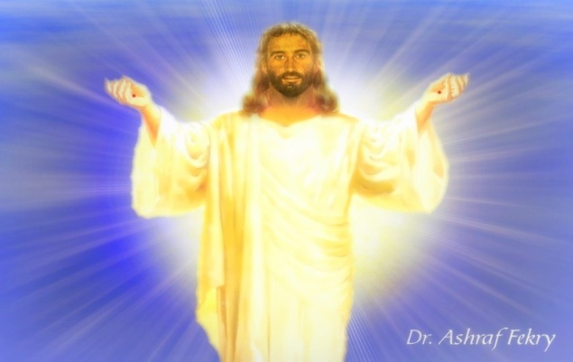](http://my.opera.com/AshraFekry/albums/showpic.dml?album=926518&picture=12681959#bigimg)

1. Jesus rose from the dead on **Easter Sunday**.

2. He re-appeared to Mary and the apostles.

**3. Thomas** doubted the resurrection of Jesus Christ.

4. Jesus went to heaven on **Ascension Day**.

**5.** Why Jesus’ death and resurrection is important to us?

* Our sins were forgiven.
* Christians got power over Satan, sin and death.
* Christians have hope for life after death (eternal life).

**Activity**

1. **Why is Easter Sunday important to Christians?**
2. **What showed that Jesus had resurrected?**
3. **Name the apostle who doubted Jesus’ resurrection.**
4. **On which day did Jesus return to heaven?**
5. ***Name the place where Jesus was crucified***
6. ***How many people entered the ark?***
7. ***When did God’s plan of salvation fulfilled?***

***TOPICAL TEST TWO***

* 1. *What is lent?*
  2. *Who tempted Jesus in the wilderness?*
  3. *Which angel brought the good news of Mary?*
  4. *On which day, did Jesus go to Jerusalem riding a donkey?*
  5. *Name the day Jesus had the last supper with his apostles*
  6. *What did the following represent during Holy Communion?*

1. *Bread*
2. *Wine* 
   1. *Match correctly list A and B*

*A B*

*Judas buried the body of Jesus*

*Thomas denied Jesus three times*

*Simon Peter betrayed Jesus Christ*

*Joseph of Arimanthea doubted Jesus’ resurrection*

* 1. *Name the books that were revealed by the following prophets.*

*Prophet Mohammed____________________*

*Prophet Musa __________________________*

*Prophet Dauda__________________________*

*Prophet Isa _____________________________*

* 1. *What are law books?*
  2. *Mention three gospel books you know*

***TYPES OF PRAYERS***

* + 1. *Supplicational prayer*
    2. *Liturgical prayer*
    3. *Petitional prayer*
    4. *Thanks giving prayer*
    5. *Praising prayer*
    6. *Invocational prayer – to ask for protection against danger*
    7. *Intercessional prayers*

***ISLAMIC PRAYERS***

*Subhi 2 – 5:00am*

*Zuhr 4 – 1:00 – 4:00pm*

*Aswir 4 - 4:00 – sunset*

*Magharib 3 - sunset – 7:30pm*

*Ishai 4 - 7:30 to dawn*

**THE END**